
Submitted by:
Name: Istiak Alam
ID: 05
Batch: 20
Course: CSE
Course Code: 1201 Assignment No: 01
Assignment Topic: Structured Programming Language

Submitted to:
A. H. M. Saiful Islam
ASSOCIATE PROFESSOR, CHAIRMAN, DEPARTMENT OF COMPUTER SCIENCE & ENGINEERING
Exercise 1:

Ans to the Question No. 01

  - Numbers in the normal decimal notation:
103e-4 = 0.0103
1.2345e+6 = 1234500
123.45e+3 = 123450

  - Numbers in C scientific notation:
1300 = 1.3e+3
123.45 = 1.2345e+2
0.00426 = 4.26e-4

Ans to the Question No.02

Data | Data Type
‘PQR’ | Variable
15E-2 35 | Invalid for middle space
‘h’ | Single character & Variable
“T” | Single character constant
-37.491 | Double Integer, real constant
.912 | Digit, Integer, real constant
4,719 | Invalid for (,) Comma, illegal number
4.5e3 | Integer, real constant
‘$’ | Single Character Constant
‘true’ | String Constants

Ans to the Question N.03
- Area, PI, and Radius are the best variable for the area of a circle in square inches. The data type of this variable is float & Double. Because we have to take the constant magnitude of π (PI) 3.14165 which is a real number & it will occupy 8 bytes. So, we have to use float & double type variable for this program.
- This variable type of number is Integer number for number of passing cars.
- The first letter of my last name is ‘S’. As the first letter of my name must be an element from the alphabets so the best data type for the first letter my name is CHAACTER or (char)

Ans to the Question N.04
In problem 4 we were given a source code and was told to display the output of the code.
- Main Program: #include <stdio.h> int main()
{
int m, n;
printf ("Enter two integers> "); scanf("%d %d", &m, &n); m = m + 5; n = 3 * n;
printf("m = %d\nn = %d\n", m, n);
}

- Output:
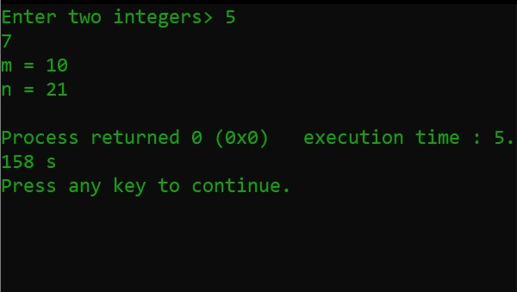
Figure 1 Output

Ans to the Question N.05
In problem 5 we were given a source code and was told to show the output displayed by the code. Where the variable ‘exp’ is supposed to be 11.
• Main program:
#include <stdio.h> int main()
{
int exp=11; printf ("My name is "); printf ("Abrar Hossain. "); printf ("\n"); printf ("I live in "); printf ("Dhaka, BD\n"); printf ("and I have %d years ", exp); printf ("of programming experience.\n");
}
• Output:
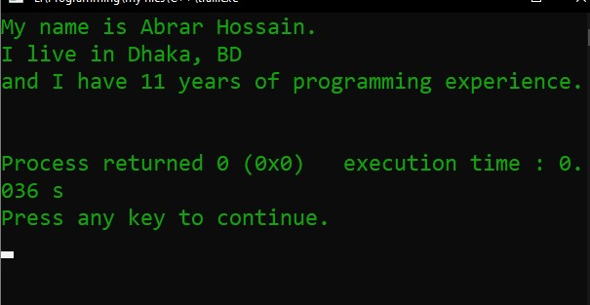
Figure 2 Output

Ans to the Question No 06
In problem number 6 we were told to modify the code in problem number 5 so that “My name is Abrar Hossain” and “I live in Dhaka, BD” is shown in the same line without running them on the same line.
- Program:
The given source code is –
printf ("My name is "); printf ("Abrar Hossain."); printf("\n"); printf ("I live in ");
printf ("Dhaka, BD\n"); printf ("and I have %d years ", exp);
printf ("of programming experience.\n");
- The modified source code is: #Include <stdio.h> int main()
{
int exp=11; printf ("My name is "); printf ("Abrar Hossain. "); printf ("I live in "); printf ("Dhaka, BD\n"); printf ("and I have %d years ", exp); printf ("of programming experience.\n"); return 0; }
- Output:
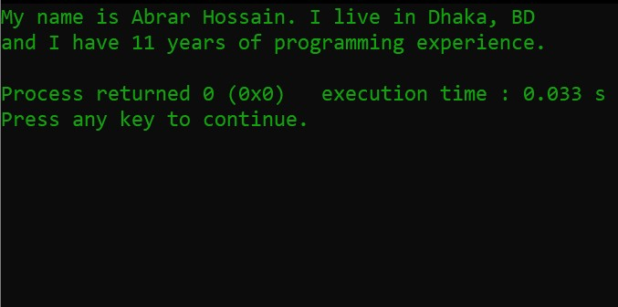
Figure 3 Output
In this code we just have to remove the 3rd line of the code. Because of that line the code displayed the desired lines separately. So, if we remove the 3rd line then “My name is Abrar Hossain” and “I live in Dhaka, BD” would appear on the same line without running them on the same line.

Ans to the Question No. 07
In problem number 7 we were told to write a program that asked the user to enter the radius of a circle and then it would compute and display the circle’s area.
And the given formula is Area = PI x Radius x Radius

And there was the value of PI is the constant macro- 3.14159.

- Program:
#include <stdio.h> int main()
{
float radius,area,PI=3.14159;

printf("Please enter the radius of a circle\n"); scanf("%f",&radius);

area = PI*radius*radius;

printf("The area of the circle is : %f\n",area);
}
- Output:
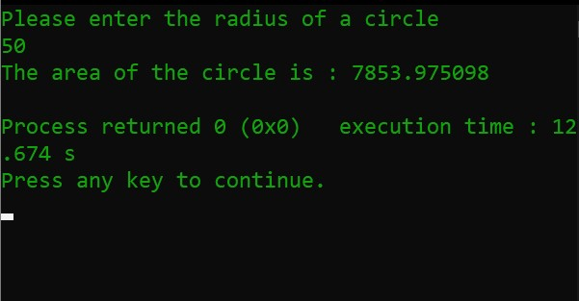
Figure 4 Output

Ans to the Question NO. 08
In problem number 8 we were given a source code and asked what the output of that code will be.
The given source code is – printf("%d\t",sizeof(6.5)); printf("%d\t",sizeof(90000)); printf("%d",sizeof('A'));
The source code used in CodeBlocks –
#include <stdio.h> int main()
{
printf("%d\t",sizeof(6.5)); printf("%d\t",sizeof(90000)); printf("%d",sizeof('A'));
}
• Output:

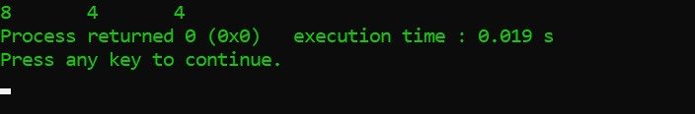
Figure 5 Output

THE END

